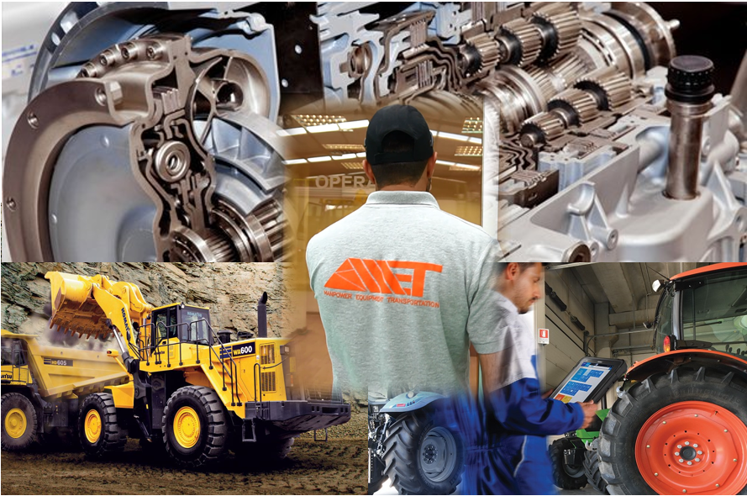

**Manpower Equipment Transportation**

T: +994 12 565 51 46 info@ametsolution.com

Azerbaijan, Baku, AZ1102 Salyan Highway 12 km

[www.ametsolution.com](http://www.ametsolution.com)

AMET **SERVICES**

**www.ametsolution.com**